Dalgo Local Dev Setup

Dalgo Local Dev Setup
A step guide to help you set up your local environment for development

Dalgo Login

Dalgo Login

- Please check your email for an invite to join the Dalgo platform similar to below:
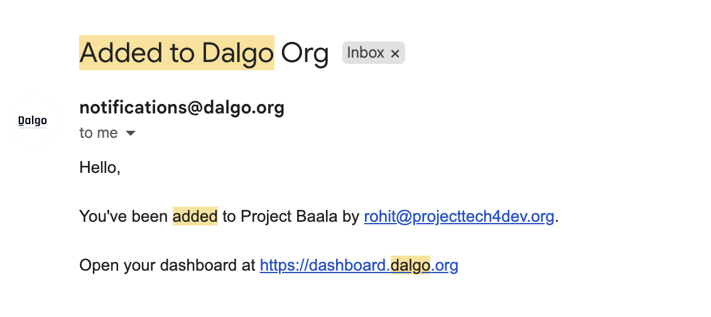
- Click on the attached link in the email to set your password.
- Go to https://insights.dalgo.org/ to find DalgoV2, our revamped Dalgo experience.
- You should be automatically logged into DalgoV2. If not, kindly login using your credentials.

VaultWarden Credentials Storage

- Using your created vaultwarden credentials, you can login to the portal here: https://vaultwarden.projecttech4dev.org/#/login
- Go to your org vault ‘<Org_Name>’ in the left menu under ‘All vaults’
- <Org_Name>: Your Orgs Datawarehouse/DB credentials

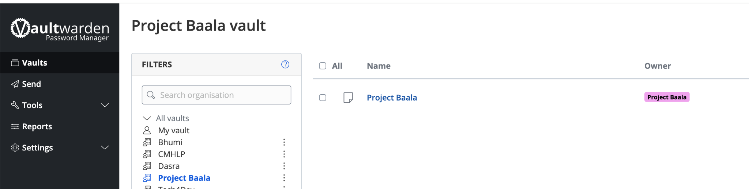

DB access locally using TablePlus

DB access locally using TablePlus

- Connect to your remote data warehouse to view your database data locally on your machine. We use an application called TablePlus to connect to DB
- Go to https://tableplus.com/download/ Download and set up the relevant version on your machine.
- Open the application. Click on ‘Create Connection’
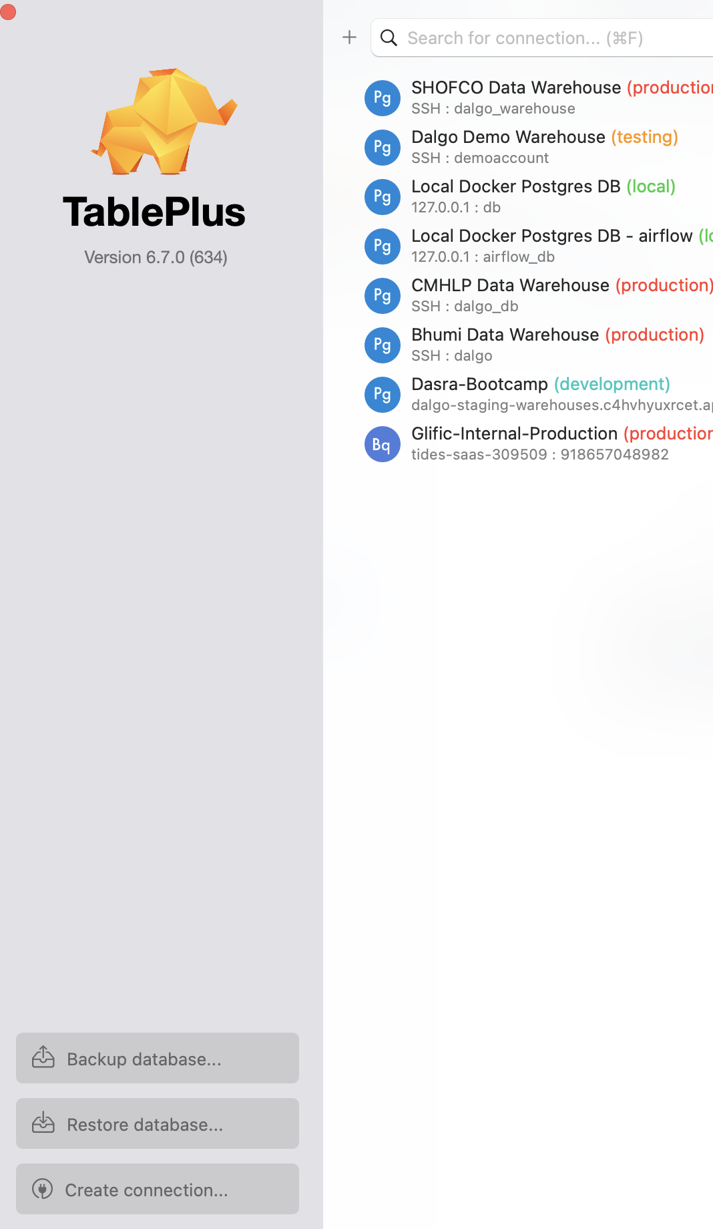

- If you are using a Postgres Data Warehouse (if set up by Dalgo) then click on ‘Postgres’. Then click ‘Create’. Otherwise set up your own data warehouse.
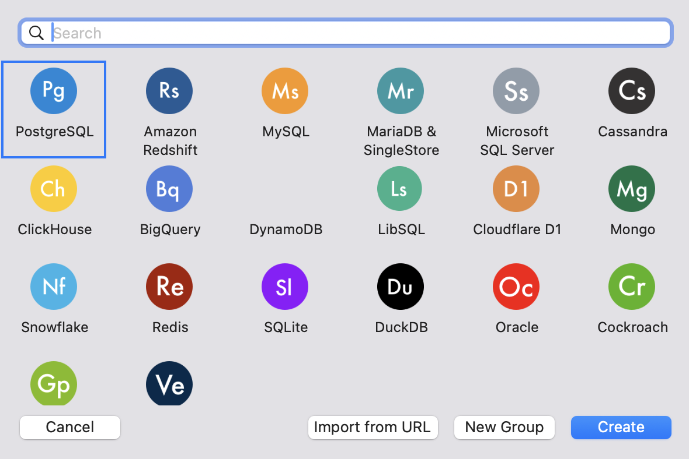

- This popup box opens up. To find the details to fill in here, follow next steps
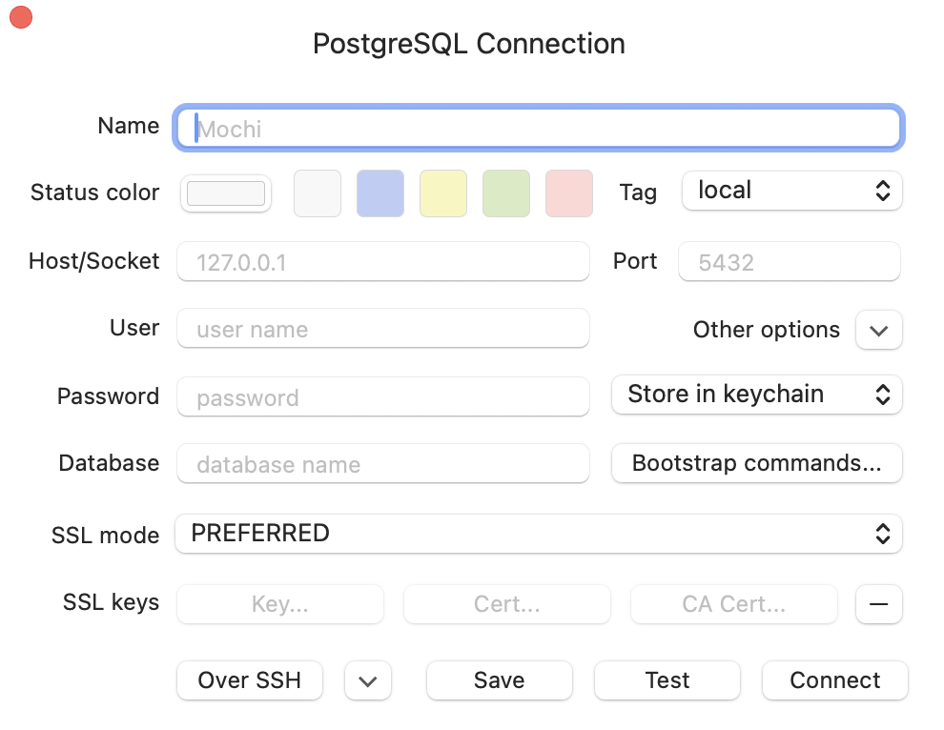
- Now, Open your org’s Dalgo platform. Go to Data->Ingest->Your Warehouse
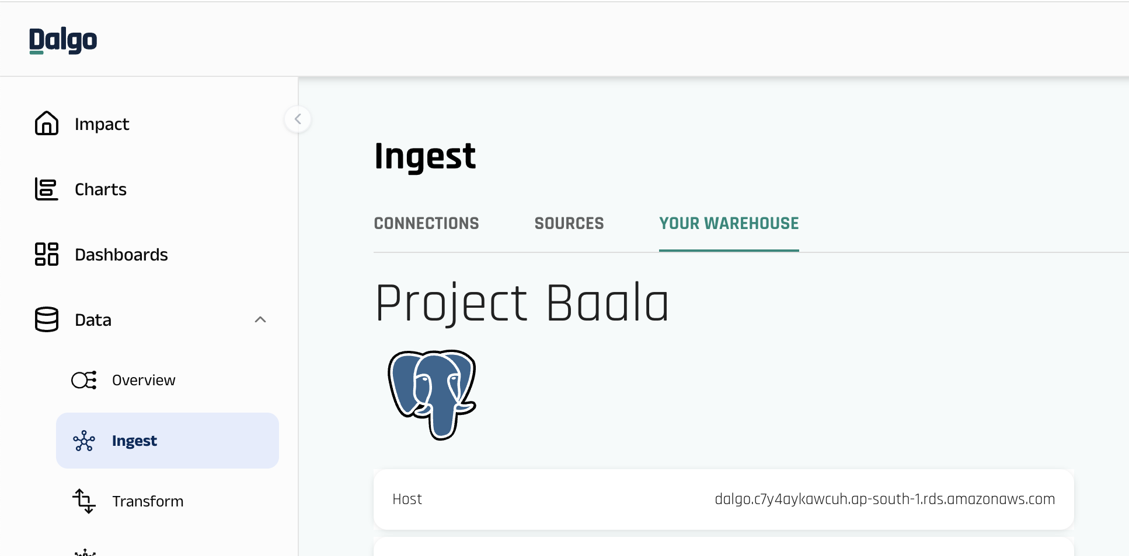

- From here copy the required data and past in the tableplus pop-up window in step 5
- Name: <Org Name> Data Warehouse
- Tag: Production
- Host: <’Host’ from Dalgo page>
- User: <’User’ from Dalgo page>
- Password: <Get from Vaultwarden Your Org’s vault>
- Database: <’Database’ from Dalgo page>

Github Desktop Setup

Github Desktop Setup
- Your DBT code has been put on a central public repository called Github.
- You can find the Org repository link here: https://github.com/DalgoT4D/dbt_<Org_Name>
- To sync the remote repository to your local machine, we will use Github Desktop.
- Download and setup your relevant version from here: https://desktop.github.com/download/
- Go to Add->Clone Repository
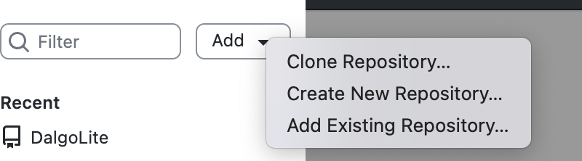
- To to URL->Paste your repository link. Then, create a new folder inside your ‘Documents’ folder from File Explorer. Then, select that local location here under ‘Local Path’
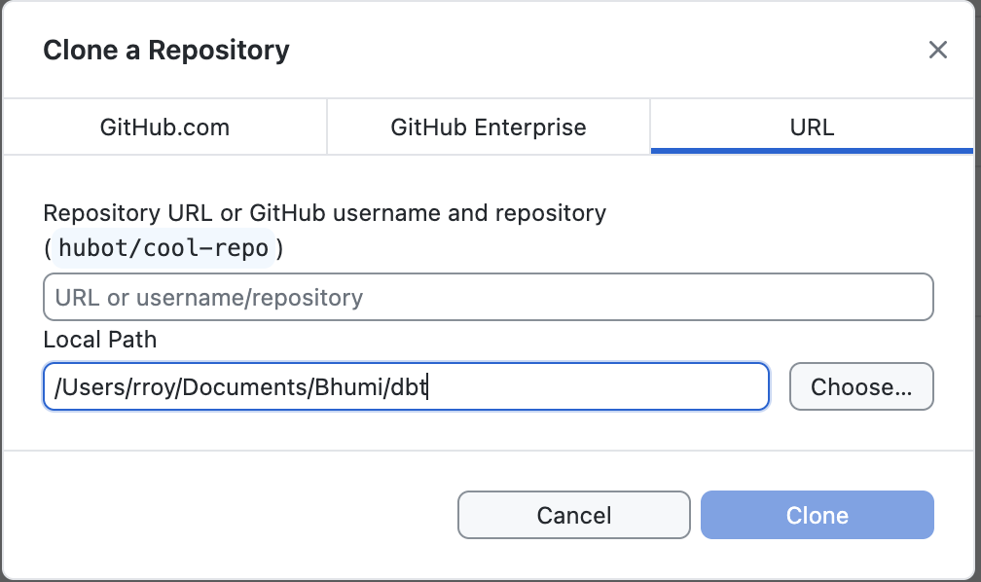
- This will set up a local copy of your repository. You can make changes to this local copy locally and once done, you can commit and push changes into the original remote repository.

Python & IDE setup

Python & IDE setup
- Set up an IDE(i.e. code editor) of your choice. We prefer Cursor: https://cursor.com/download
- Download & install cursor. Grant any necessary permissions.
- Create an account/Sign in Cursor
- In the top menu, Go to Terminal->New Terminal
- Go to Inside the newly opened terminal at the bottom
- We need python to run DBT. To check python version installation on your local machine, run the following command in the terminal: python3 --version
- If you see a python version then you can proceed. But if not installed is shown then you need to install python first. Download & setup: https://www.python.org/downloads/
- Mark the checkboxes as shown & click ‘Install Now’ (for easiest installation)
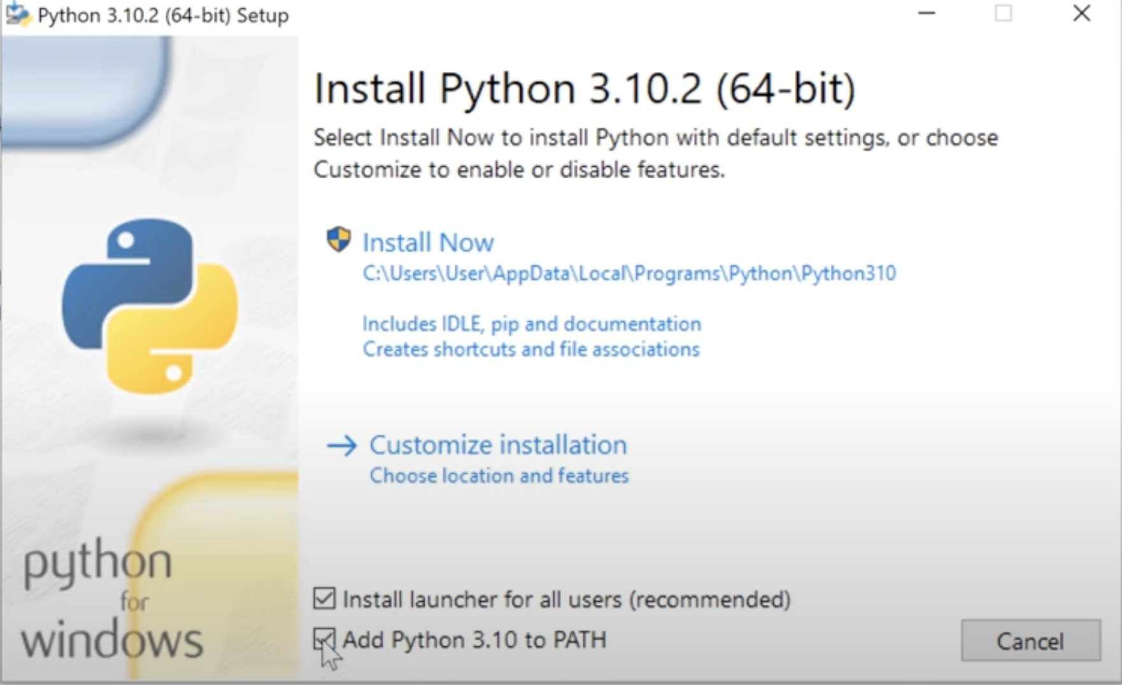

For detailed installation guide follow this tutorial: How To Install Python In 3 Minutes (For Beginners)
- Once installation is complete, open cursor & run the command in step 5 again. You should see a response with a python version.

SSH Setup

SSH Setup
- Inside cursor, open a new terminal.
- Inside the terminal, towards the top right corner, you will see a dropdown arrow. Clicking it reveals the different types of terminals we can open. Select the ‘bash’ option from here.
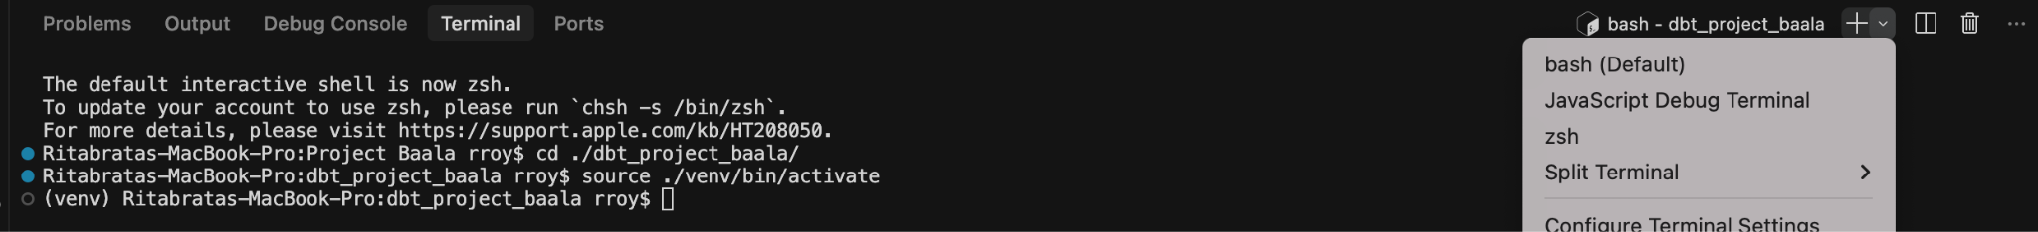
- Go to the newly opened ‘bash’ terminal
- Type this command and run after putting in your email :
ssh-keygen -t rsa -b 4096 -C "<your email address>"
- Keep pressing enter in response to the prompts on the screen
- Once the process is complete, Go to your file explorer & go to ‘Users’->’your_username_folder’
- Unhide all folders (on mac: cmd+shift+.)
- Open the ‘.ssh’ folder. You should atleast see two files ‘id_rsa’ & ‘id_rsa.pub’
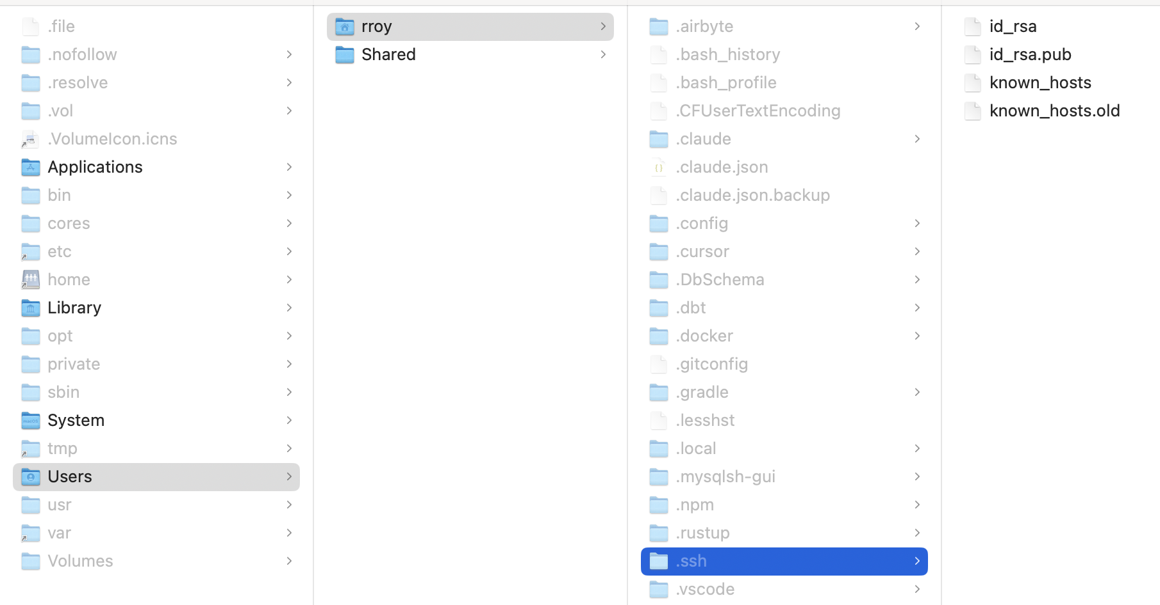
- ‘id_rsa’ is your private security key & ‘id_rsa.pub’ is your public identification key. Keep both of them safe.
- Contact your Dalgo PoC and share with them your public key (i.e. the ‘id_rsa.pub’ file). They will put your public key on the jump server so that you can securely connect to it from your local machine.
- Once your key has been put on the server, the PoC will let you know.

DBT Setup

DBT Setup
- Go to Cursor that was installed previously (or your preferred IDE)
- Open the local folder containing your DBT code (configured in Github step)
- In the top menu, Go to Terminal->New Terminal
- Go to Inside the newly opened terminal at the bottom
- Create a virtual environment with command: python3 -m venv myenv
- Activate your myenv virtual env(Win): .\myenv\Scripts\activate
- You should see the terminal’s line like below reflecting your virtual env’s name (i.e. myenv)
- Run command ‘pip install -r requirements.txt’. This will install all necessary python libraries for coding. (list mentioned in the ‘requirements.txt’ file)
- Once installation is complete, run command ‘dbt deps’. This will install necessary dbt libraries for dbt processing (list mentioned in the ‘packages.yml’ file)

DBT Profile setup
- Once the dbt installation is complete, Go to your file explorer & go to ‘Users’->’your_username_folder’
- Unhide all folders (on mac: cmd+shift+.)
- Open the ‘.dbt’ folder. If not available create it.
- Inside, create a new file and name it to ‘profiles.yml’
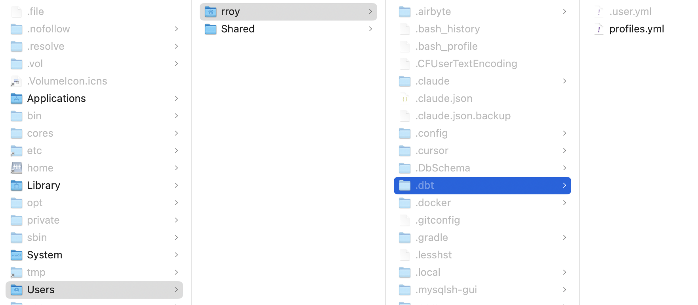

- dbt_<org_name>:
- outputs:
- prod:
- dbname: <db_name>
- host: localhost
- pass: <password>
- port: 5432
- schema: prod
- threads: 4
- type: postgres
- user: <username>
- dev:
- dbname: <db_name>
- host: localhost
- pass: <password>
- port: 5432
- schema: dev
- threads: 4
- type: postgres
- user: <username>
- target: dev

You can find all the above credentials inside your vaultwarden vault. Login into vaultwarden as you did in the previous step.

